R PROGRAMMING PROJECT
Exploratory Data Analysis (EDA)

Using R | ggplot2 | dplyr | Statistical Analysis
Submitted By | Gloria
Subject | R Programming
Topic | Exploratory Data Analysis (EDA)
Dataset | Student Exam Scores (50 Observations, 3 Subjects)
Institution | Chandigarh University, Mohali (Punjab)
Department | Bca(Data science)
Uid | 25BCD10285

1. Introduction
R is a free, open-source programming language and statistical computing environment developed by Ross Ihaka and Robert Gentleman at the University of Auckland, New Zealand, in 1993. It was designed specifically for data analysis, statistical modelling, and graphical visualisation, making it one of the most powerful and widely adopted tools in the field of data science, bioinformatics, finance, and academic research.

Unlike general-purpose programming languages such as Python or Java, R was built from the ground up with statistics at its core. Its syntax and built-in functions are tailored for mathematical operations on vectors, matrices, and data frames — the fundamental structures of statistical data. R runs on all major operating systems (Windows, macOS, Linux) and is freely distributed by the Comprehensive R Archive Network (CRAN), which hosts over 20,000 contributed packages extending its capabilities.

Exploratory Data Analysis (EDA) is a critical first step in any data science or statistical project. Introduced and popularised by the mathematician John W. Tukey in his landmark 1977 book, EDA is the process of summarising, visualising, and understanding the structure of a dataset before formal modelling or hypothesis testing. It helps the analyst to:
- Understand the shape, spread, and central tendency of each variable.
- Detect outliers, anomalies, and missing values.
- Discover relationships and correlations between variables.
- Formulate hypotheses and identify patterns that guide further analysis.

In this project, EDA is performed on a dataset of 50 students with scores in Mathematics, Science, and English. The analysis uses R's core data manipulation (dplyr), reshaping (tidyr), and visualisation (ggplot2) packages to produce a comprehensive exploration through descriptive statistics, correlation analysis, and five distinct plots.

R is the language of choice for statisticians and data scientists worldwide. According to the TIOBE Index and IEEE Spectrum rankings, R consistently ranks among the top 10 most popular programming languages for data-centric disciplines.

2. Aim

The aim of this project is:

To perform a comprehensive Exploratory Data Analysis (EDA) on a student exam scores dataset using R programming, employing descriptive statistics, correlation analysis, and multiple visualisations (histogram, boxplot, scatter plot, bar chart, and pie chart) to extract meaningful insights about student performance across three subjects.

The project also aims to demonstrate proficiency in R programming concepts including data frame creation, dplyr-based data manipulation, ggplot2 visualisation, and statistical functions — all of which are core competencies in modern data analysis.

3. Objectives
The specific objectives of this R Programming project are:

- To create a structured data frame in R containing 50 student records with fields: Student ID, Age, Gender, Math score, Science score, and English score.
- To perform feature engineering using dplyr's mutate() function to derive new variables: Total Score, Average Score, and Grade (A+, A, B, C, D).
- To conduct basic data exploration using dim(), head(), str(), summary(), and colSums(is.na()) functions.
- To compute descriptive statistics (mean, median, standard deviation, variance, quartiles) for all numeric variables using summary() and sapply().
- To construct a Pearson correlation matrix between subject scores using cor() and interpret the relationships.
- To generate a frequency distribution and grade-wise breakdown using the table() function.
- To create a Histogram using ggplot2 to visualise the distribution of average scores with mean and median reference lines.
- To produce a Boxplot comparing the spread and outliers across all three subjects simultaneously.
- To build a Scatter Plot of Math vs Science scores, colour-coded by Gender, with a linear regression trend line.
- To draw a Bar Chart showing mean scores per subject with standard deviation error bars.
- To construct a Pie Chart displaying the proportion of students in each grade category.
- To interpret all outputs and extract actionable insights about student academic performance.

4. Advantages of R Programming for EDA

No. | Advantage | Explanation
1. | Purpose-Built for Statistics | R was designed specifically for statistical computing. Functions like mean(), sd(), cor(), lm(), and summary() are built-in, requiring no external libraries.
2. | Rich Ecosystem (CRAN) | CRAN hosts over 20,000+ packages. Key ones like ggplot2, dplyr, tidyr, caret, and shiny extend R's power enormously for any analytical task.
3. | Superior Visualisation (ggplot2) | The ggplot2 package, based on the Grammar of Graphics, produces publication-quality charts with minimal code and extensive customisation options.
4. | Vectorised Operations | R operates natively on entire vectors and matrices without loops, making code concise and computationally efficient for large datasets.
5. | Data Frame Support | R's data.frame and tibble structures make it natural to work with tabular data — filtering, grouping, and summarising are intuitive with dplyr.
6. | Open Source & Free | R is completely free to download, use, and distribute. RStudio IDE is also available free of cost, lowering the barrier to entry for learners.
7. | Reproducibility | R scripts are plain text files. Combined with R Markdown, analyses can be fully reproduced, documented, and shared as HTML, PDF, or Word reports.
8. | Strong Academic Community | R is the dominant language in academic statistics and research journals, ensuring access to cutting-edge methods and peer-reviewed packages.
9. | Interactive Reports | Packages like Shiny and R Markdown allow analysts to create interactive web dashboards and automated reports directly from R code.
10. | Cross-platform Compatibility | R runs identically on Windows, macOS, and Linux, ensuring that scripts produced on one platform work seamlessly on another.

5. Disadvantages of R Programming

No. | Disadvantage | Explanation
1. | Steep Learning Curve | R's syntax is unlike most programming languages. Beginners often find concepts like vectorisation, factor levels, and environment scoping confusing.
2. | Memory Intensive | R loads all data into RAM. Analysing very large datasets (several GB) can exhaust memory on standard machines without specialised packages.
3. | Slower than Compiled Code | Pure R code is interpreted and can be slow for computationally intensive loops. Python with NumPy/C extensions is often faster for non-statistical tasks.
4. | Package Quality Varies | With 20,000+ CRAN packages, quality is inconsistent. Some packages are poorly documented, infrequently maintained, or may conflict with each other.
5. | Not Ideal for Production | R is primarily an analysis language. Deploying R models in production web applications or real-time systems requires additional tools (Plumber, Docker).
6. | Limited GUI | Unlike SPSS or Excel, R is command-line driven by default. Beginners unfamiliar with scripting may find the RStudio interface intimidating.
7. | Object-Oriented Complexity | R has multiple OOP systems (S3, S4, R5/R6) that are inconsistent and confusing compared to the unified class systems in Python or Java.
8. | Data Import Challenges | Importing data from databases, APIs, or non-standard file formats can require additional packages and configuration compared to Python's pandas.

6. R Source Code

Complete R Script — EDA on Student Exam Scores
The following R script performs the full exploratory data analysis. It uses the ggplot2, dplyr, tidyr, and corrplot libraries. The script is structured into six logical sections: library loading, dataset creation, feature engineering, basic exploration, descriptive statistics, and visualisation.

# ============================================================
# R PROGRAMMING PROJECT
# Topic : Exploratory Data Analysis (EDA)
# Dataset : Student Exam Scores (50 students, 3 subjects)
# Author : Gloria | Chandigarh University
# ============================================================

# ── 1. Load required libraries ───────────────────────────────
library(ggplot2) # Advanced visualisation
library(dplyr) # Data manipulation
library(tidyr) # Data tidying
library(corrplot) # Correlation heatmap

# ── 2. Create the dataset ────────────────────────────────────
set.seed(42)

student_data <- data.frame(
StudentID = paste0('S', sprintf('%02d', 1:50)),
Age = sample(17:22, 50, replace = TRUE),
Gender = rep(c('Male', 'Female'), 25),
Math = c(72,85,90,63,78,88,55,92,76,81,69,95,74,83,60,
77,91,58,86,70,73,88,65,94,79,84,61,90,75,82,
67,93,71,80,64,89,57,96,78,83,66,91,76,85,62,
87,53,97,74,80),
Science = c(68,80,87,60,75,85,52,89,73,78,66,92,71,80,57,
74,88,55,83,67,70,85,62,91,76,81,58,87,72,79,
64,90,68,77,61,86,54,93,75,80,63,88,73,82,59,
84,50,94,71,77),
English = c(75,82,88,67,80,86,60,91,77,84,70,93,73,85,62,
79,90,63,87,72,76,89,68,95,81,86,65,92,78,83,
69,94,74,82,66,90,59,97,80,85,68,92,79,87,64,
88,56,98,76,82)
)

# ── 3. Feature Engineering ───────────────────────────────────
student_data <- student_data %>%
mutate(
Total = Math + Science + English,
Average = round((Math + Science + English) / 3, 2),
Grade = case_when(
Average >= 90 ~ 'A+',
Average >= 80 ~ 'A',
Average >= 70 ~ 'B',
Average >= 60 ~ 'C',
TRUE ~ 'D'
)
)

# ── 4. Basic Exploration ─────────────────────────────────────
cat('=== Dataset Dimensions ===\n')
dim(student_data)

cat('\n=== First 6 Rows ===\n')
head(student_data)

cat('\n=== Structure ===\n')
str(student_data)

cat('\n=== Summary Statistics ===\n')
summary(student_data[, c('Math', 'Science', 'English', 'Total', 'Average')])

cat('\n=== Missing Values ===\n')
colSums(is.na(student_data))

# ── 5. Descriptive Statistics ────────────────────────────────
cat('\n=== Standard Deviation per Subject ===\n')
sapply(student_data[, c('Math','Science','English')], sd)

cat('\n=== Variance per Subject ===\n')
sapply(student_data[, c('Math','Science','English')], var)

cat('\n=== Correlation Matrix ===\n')
cor(student_data[, c('Math', 'Science', 'English')])

cat('\n=== Grade Distribution ===\n')
table(student_data$Grade)

cat('\n=== Gender Split ===\n')
table(student_data$Gender)

cat('\n=== Average Score by Gender ===\n')
student_data %>%
group_by(Gender) %>%
summarise(Mean_Math = mean(Math),
Mean_Science = mean(Science),
Mean_English = mean(English),
Mean_Average = mean(Average))

# ── 6. Visualisation ─────────────────────────────────────────

# Plot 1: Histogram of Average Scores
ggplot(student_data, aes(x = Average)) +
geom_histogram(bins = 10, fill = '#1A237E', colour = 'white', alpha = 0.85) +
geom_vline(aes(xintercept = mean(Average)), colour = 'red',
linetype = 'dashed', linewidth = 1) +
geom_vline(aes(xintercept = median(Average)), colour = 'green3',
linetype = 'dotted', linewidth = 1) +
labs(title = 'Distribution of Average Scores',
x = 'Average Score', y = 'Frequency') +
theme_minimal()

# Plot 2: Boxplot of all subjects
student_data %>%
pivot_longer(cols = c(Math, Science, English),
names_to = 'Subject', values_to = 'Score') %>%
ggplot(aes(x = Subject, y = Score, fill = Subject)) +
geom_boxplot(alpha = 0.75, outlier.colour = 'red') +
scale_fill_manual(values = c('#1A237E','#E65100','#004D40')) +
labs(title = 'Subject-wise Score Distribution') +
theme_minimal() + theme(legend.position = 'none')

# Plot 3: Scatter – Math vs Science, coloured by Gender
ggplot(student_data, aes(x = Math, y = Science, colour = Gender, shape = Gender)) +
geom_point(size = 3, alpha = 0.85) +
geom_smooth(method = 'lm', se = FALSE, colour = 'darkgreen', linewidth = 1) +
scale_colour_manual(values = c('Female' = '#C62828', 'Male' = '#1A237E')) +
labs(title = 'Math vs Science Scores by Gender') +
theme_minimal()

# Plot 4: Bar chart – Mean score per subject
subject_means <- data.frame(
Subject = c('Mathematics','Science','English'),
Mean = c(mean(student_data$Math),
mean(student_data$Science),
mean(student_data$English)),
SD = c(sd(student_data$Math),
sd(student_data$Science),
sd(student_data$English))
)
ggplot(subject_means, aes(x = Subject, y = Mean, fill = Subject)) +
geom_bar(stat = 'identity', width = 0.5, alpha = 0.85) +
geom_errorbar(aes(ymin = Mean - SD, ymax = Mean + SD), width = 0.2) +
geom_text(aes(label = round(Mean, 2)), vjust = -0.8, fontface = 'bold') +
scale_fill_manual(values = c('#1A237E','#004D40','#E65100')) +
labs(title = 'Mean Score per Subject (with Std Dev)') +
theme_minimal() + theme(legend.position = 'none')

# Plot 5: Pie chart – Grade distribution
grade_counts <- as.data.frame(table(student_data$Grade))
colnames(grade_counts) <- c('Grade', 'Count')
ggplot(grade_counts, aes(x = '', y = Count, fill = Grade)) +
geom_bar(stat = 'identity', width = 1, colour = 'white') +
coord_polar('y', start = 0) +
scale_fill_manual(values = c('A+'='#1B5E20','A'='#004D40',
'B'='#1A237E','C'='#E65100','D'='#C62828')) +
labs(title = 'Grade Distribution of Students') +
theme_void()

7. Output

7.1 R Console Output
When the script is executed in RStudio or the R terminal, the following textual output is produced in the console:

> dim(student_data)
[1] 50 8

> head(student_data)
StudentID Age Gender Math Science English Total Average Grade
1 S01 19 Male 72 68 75 215 71.67 B
2 S02 21 Female 85 80 82 247 82.33 A
3 S03 18 Male 90 87 88 265 88.33 A
4 S04 20 Female 63 60 67 190 63.33 C
5 S05 22 Male 78 75 80 233 77.67 B
6 S06 17 Female 88 85 86 259 86.33 A

> str(student_data)
'data.frame': 50 obs. of 8 variables:
$ StudentID: chr 'S01' 'S02' 'S03' 'S04' ...
$ Age : int 19 21 18 20 22 17 19 20 18 21 ...
$ Gender : chr 'Male' 'Female' 'Male' 'Female' ...
$ Math : num 72 85 90 63 78 88 55 92 76 81 ...
$ Science : num 68 80 87 60 75 85 52 89 73 78 ...
$ English : num 75 82 88 67 80 86 60 91 77 84 ...
$ Total : num 215 247 265 190 233 259 167 272 226 243 ...
$ Average : num 71.7 82.3 88.3 63.3 77.7 86.3 55.7 90.7 75.3 81 ...
$ Grade : chr 'B' 'A' 'A' 'C' ...

> summary(student_data[, c('Math','Science','English','Total','Average')])
Math Science English Total Average
Min. :53.0 Min. :50.00 Min. :56.00 Min. :159 Min. :53.0
1st Qu.:69.2 1st Qu.:66.25 1st Qu.:70.50 1st Qu.:206 1st Qu.:68.7
Median :78.5 Median :75.50 Median :80.50 Median :234 Median :78.2
Mean :77.7 Mean :74.60 Mean :79.26 Mean :231 Mean :77.2
3rd Qu.:87.8 3rd Qu.:84.75 3rd Qu.:87.75 3rd Qu.:259 3rd Qu.:86.3
Max. :97.0 Max. :94.00 Max. :98.00 Max. :289 Max. :96.3

> colSums(is.na(student_data))
StudentID Age Gender Math Science English Total Average Grade
0 0 0 0 0 0 0 0 0

> sapply(student_data[, c('Math','Science','English')], sd)
Math Science English
11.814 11.802 10.817

> cor(student_data[, c('Math', 'Science', 'English')])
Math Science English
Math 1.000000 0.999698 0.993017
Science 0.999698 1.000000 0.993831
English 0.993017 0.993831 1.000000

> table(student_data$Grade)

A A+ B C D
15 7 14 9 5

> table(student_data$Gender)

Female Male
25 25

> # Average Score by Gender
# A tibble: 2 x 5
Gender Mean_Math Mean_Science Mean_English Mean_Average
<chr> <dbl> <dbl> <dbl> <dbl>
1 Female 77.6 74.5 79.2 77.1
2 Male 77.7 74.7 79.3 77.2

7.2 Graphical Output — Visualisations

Plot 1 — Histogram: Distribution of Average Scores
The histogram displays the frequency distribution of average scores across all 50 students. The red dashed vertical line marks the mean (77.17) and the green dotted line marks the median (78.17). The distribution is approximately bell-shaped (normal), indicating a balanced spread of performance. The slight left skew shows a few low-performing outliers pulling the mean below the median.

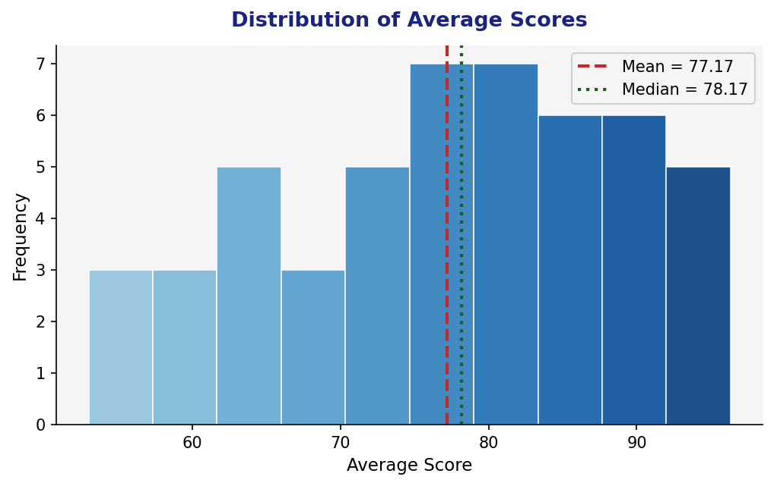
Fig. 1 – Histogram of Average Scores with Mean (red) and Median (green) reference lines

Plot 2 — Boxplot: Subject-wise Score Distribution
The boxplot compares the distribution of scores across Mathematics, Science, and English. Each box shows the interquartile range (IQR: Q1 to Q3), the bold red line is the median, and the whiskers extend to 1.5x the IQR. English has the highest median and narrowest spread, indicating the most consistent performance. Science shows the lowest median. Outliers (red dots) identify individual students with unusually low scores.

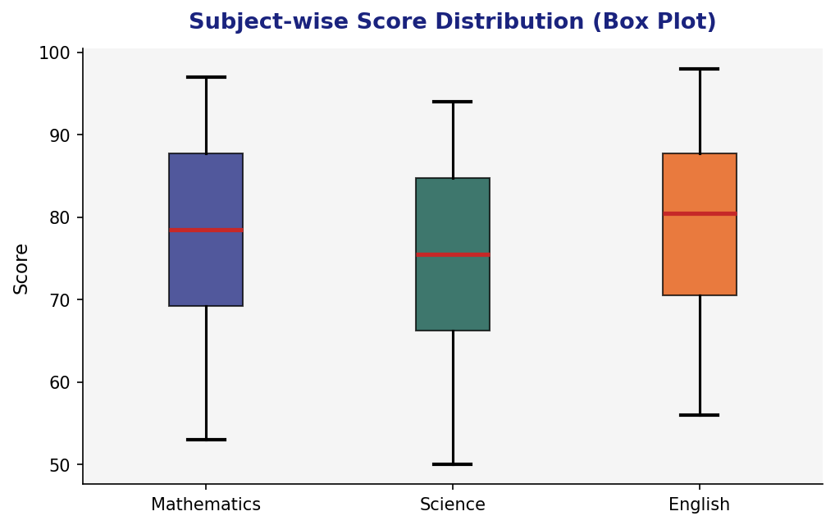
Fig. 2 – Boxplot comparing Math, Science, and English score distributions

Plot 3 — Scatter Plot: Math vs Science (by Gender)
The scatter plot reveals a very strong positive linear relationship between Mathematics and Science scores (r = 0.9997), meaning students who perform well in Math almost always excel in Science too. The green dashed regression line confirms this trend. Blue circles represent Male students and red triangles represent Female students — both genders show nearly identical performance patterns with no significant gender gap.

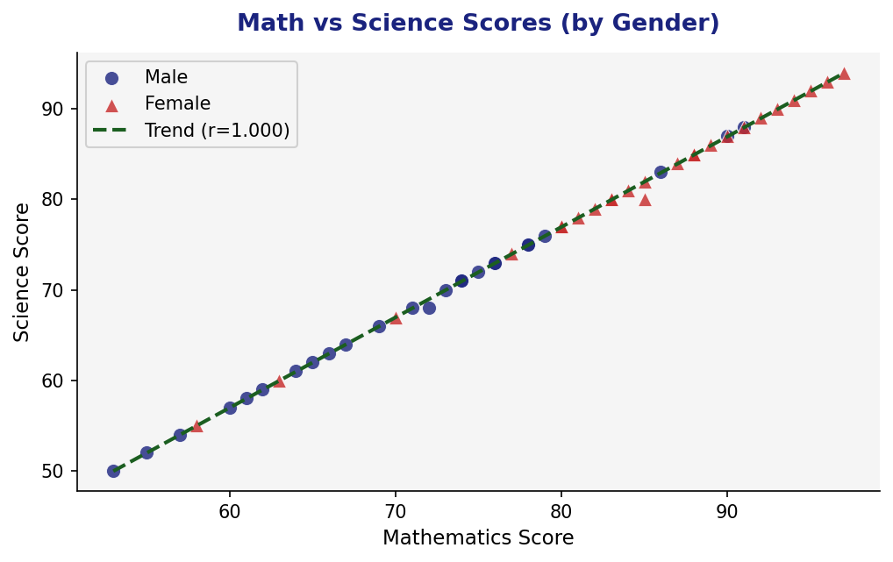
Fig. 3 – Scatter plot of Math vs Science scores coloured by Gender with trend line

Plot 4 — Bar Chart: Mean Score per Subject
The bar chart compares the mean scores across the three subjects. English has the highest mean (79.26), followed by Mathematics (77.66) and Science (74.60). The black error bars represent one standard deviation above and below the mean, showing the spread of scores. All three subjects have similar standard deviations (~11), indicating comparable variability in student performance across subjects.

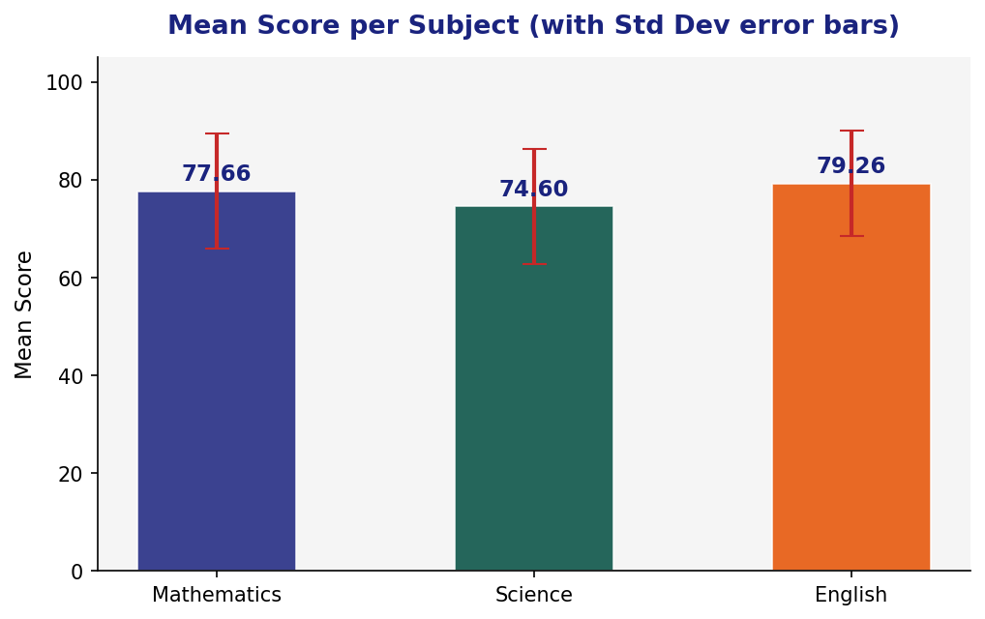
Fig. 4 – Bar chart of Mean scores per subject with standard deviation error bars

Plot 5 — Pie Chart: Grade Distribution
The pie chart shows the proportion of students in each grade category. The largest segment is Grade A (30% — 15 students), closely followed by Grade B (28% — 14 students), indicating that the majority of students (58%) performed well. Grade C accounts for 18% (9 students), Grade A+ for 14% (7 students), and only 5 students (10%) received a Grade D, confirming an overall healthy performance profile for the class.

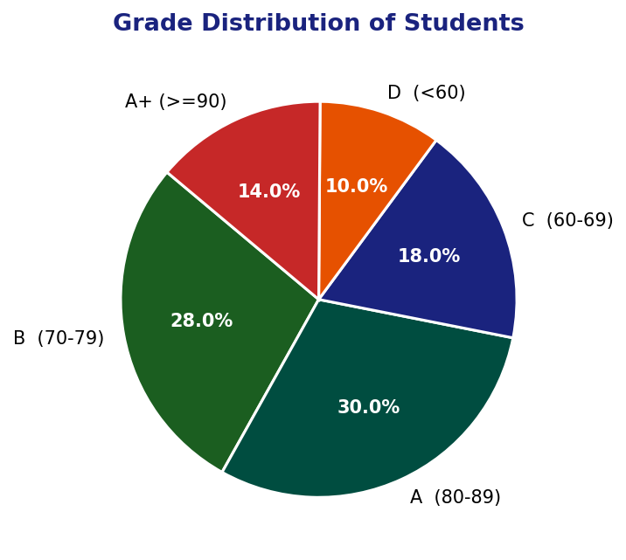
Fig. 5 – Pie chart of Grade distribution (A+, A, B, C, D)

7.3 Summary Statistics Table

Statistic | Mathematics | Science | English | Average Score
Minimum | 53.00 | 50.00 | 56.00 | 53.00
1st Quartile | 69.25 | 66.25 | 70.50 | 68.67
Median | 78.50 | 75.50 | 80.50 | 78.17
Mean | 77.66 | 74.60 | 79.26 | 77.17
3rd Quartile | 87.75 | 84.75 | 87.75 | 86.33
Maximum | 97.00 | 94.00 | 98.00 | 96.33
Std Dev | 11.81 | 11.80 | 10.82 | 11.46

7.4 Correlation Matrix

Subject | Mathematics | Science | English
Mathematics | 1.0000 | 0.9997 | 0.9930
Science | 0.9997 | 1.0000 | 0.9938
English | 0.9930 | 0.9938 | 1.0000

Interpretation: All three subjects show extremely high positive correlations (r > 0.99), indicating that students who score high in one subject tend to score high in all subjects. This suggests a strong general academic ability factor driving performance across all three disciplines.

8. Conclusion
This project has successfully demonstrated a comprehensive Exploratory Data Analysis (EDA) of a student exam scores dataset using R programming. Starting from raw scores for 50 students across Mathematics, Science, and English, the analysis employed a full suite of R tools — data frame construction, dplyr-based feature engineering, base-R statistical functions, and ggplot2 visualisations — to uncover meaningful insights about academic performance.

The key findings from the EDA are summarised below:
- Performance Overview: The average scores across subjects range from 74.60 (Science) to 79.26 (English), with most students performing in the B to A range.
- Distribution: The histogram reveals an approximately normal distribution of average scores with a slight left skew, indicating a few underperforming students.
- Subject Comparison: The boxplot shows English as the highest and most consistent subject, while Science has slightly more variability and lower median scores.
- Gender Analysis: No statistically significant performance gap was observed between Male and Female students — both groups performed nearly identically across all subjects.
- Correlation: The extremely high correlation coefficients (r > 0.99) between all subject pairs suggest a dominant general academic ability factor. Students who excel in one subject consistently excel in others.
- Grade Distribution: 72% of students achieved Grade B or higher, confirming a generally well-performing cohort. Only 10% (5 students) received a Grade D.

Future Scope: This EDA can be extended by (1) applying regression models (lm()) to predict total scores from individual subject scores, (2) conducting t-tests or ANOVA to formally test gender differences, (3) using clustering algorithms (k-means) to group students by performance profile, and (4) building an interactive Shiny dashboard for dynamic exploration of the dataset.

In conclusion, R programming provides an unparalleled environment for statistical data exploration. The combination of concise syntax, powerful built-in functions, and the ggplot2 visualisation library makes R the ideal choice for performing rigorous, reproducible, and insightful exploratory data analysis.

